Images to print out in larger format
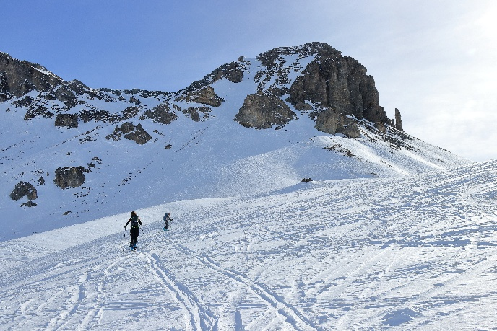 | 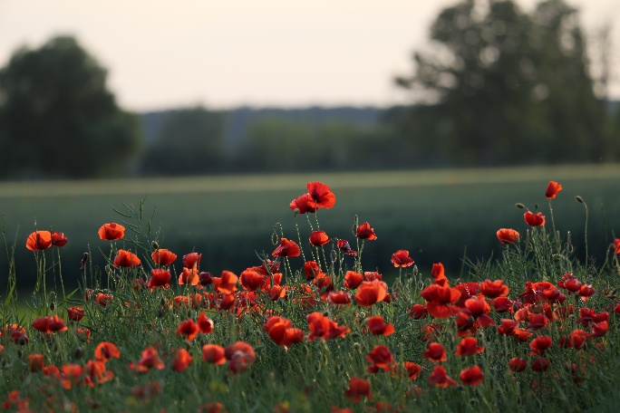
Image by Tom from Pixabay  https://pixabay.com/photos/mountains-rocks-snow-winter-7831286/ | Image by Goran Horvat from Pixabay  https://pixabay.com/photos/red-poppies-flowers-blooming-meadow-5206943/
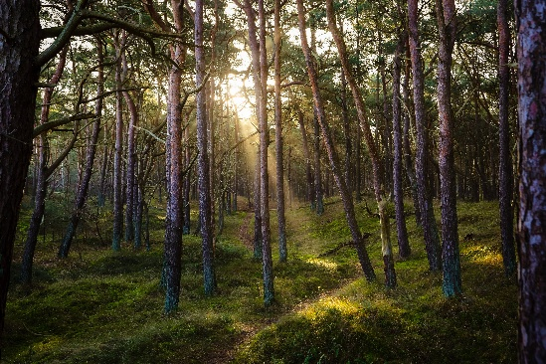 | 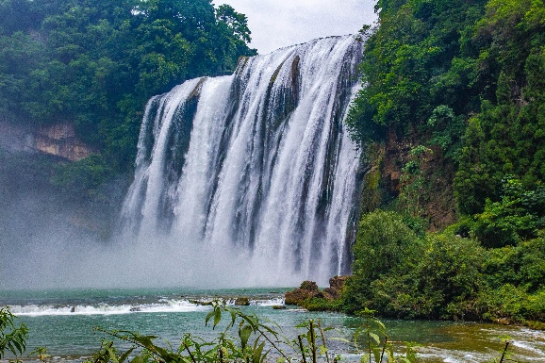
Image by Ma_Frank from Pixabay  https://pixabay.com/photos/forest-nature-sun-sunbeams-idyllic-7311484/ | Image by meilin2010 from Pixabay  https://pixabay.com/photos/guiyang-%e9%bb%84%e6%9e%9c%e6%a0%91-waterfall-5256821/
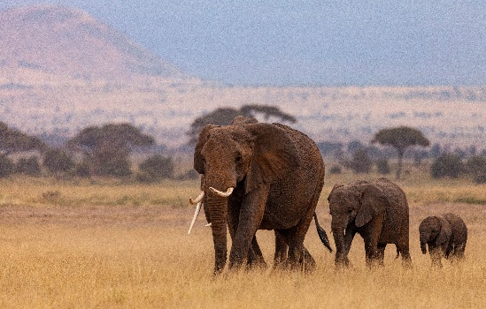 | 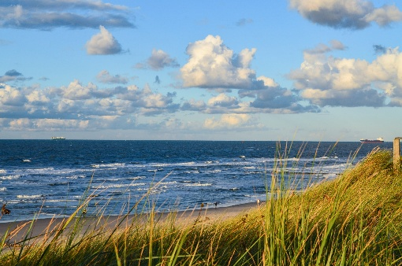
Image by Simon Oberthaler from Pixabay  https://pixabay.com/photos/elephants-herd-pachyderms-mammals-8171393/ | Image by Henning Westerkamp from Pixabay  https://pixabay.com/photos/baltic-sea-beach-germany-coast-sea-4136488/

